Physics 100 Name: ________________________________
Musical Instrument Keyboards and Fingerboards (in the Western World)

Note  Name | half steps  up from starting note | Frequency (Hz) | Ratio: Current frequency / Previous frequency | Ratio of wavelength to starting note wavelength
A | 0 | 440 | NA | 1
A# (or B♭) | 1 | 466 | 1.059 | 0.944
B | 2 | 494 | 1.059 | 0.891
C | 3 | 523 | 1.059 | 0.841
C# (or D♭) | 4 | 554 | 1.059 | 0.794
D | 5 | 587 | 1.059 | 0.749
D# (or E♭) | 6 | 622 | 1.059 | 0.707
E | 7 | 659 | 1.059 | 0.667
F | 8 | 698 | 1.059 | 0.630
F# (or G♭) | 9 | 740 | 1.059 | 0.595
G | 10 | 784 | 1.059 | 0.561
G# (or A♭) | 11 | 831 | 1.059 | 0.530
A | 12 | 880 | 1.059 | 0.5
A# (or B♭) | 13 | 932 | 1.059 | 0.472
B | 14 | 988 | 1.059 | 0.445
C | 15 | 1047 | 1.059 | 0.420
C# (or D♭) | 16 | 1109 | 1.059 | 0.397
D | 17 | 1175 | 1.059 | 0.375
D# (or E♭) | 18 | 1245 | 1.059 | 0.354
E | 19 | 1319 | 1.059 | 0.334
F | 20 | 1397 | 1.059 | 0.315
F# (or G♭) | 21 | 1480 | 1.059 | 0.297
G | 22 | 1568 | 1.059 | 0.281
G# (or A♭) | 23 | 1661 | 1.059 | 0.265
A | 24 | 1760 | 1.059 | 0.25
1. When musicians play a 1-octave scale, they play ________ notes. When we hear the musical notes at the bottom and top of a 1-octave scale, our ears perceive those notes as being the same notes, even though one sounds higher and one sounds lower.

2. When two notes are separated by an octave, the higher note has a frequency that is

___________________ the frequency of the

lower note.

For example, a musical note with a frequency of 110Hz is an A. If we start singing at that pitch and move gradually upward, we will reach the next A when we get to ______Hz. The next A after that will be heard at _______Hz.

3. The music that most of us listen to uses notes

that divide each octave into ________ equal parts. Each of these equal parts is called a

_________________________

4. A one octave jump in pitch represents a ______________________________ of sound wave frequency.

5. A two octave increase in pitch represents a 2⁽ ⁾ increase in frequency.
6. A three octave increase in pitch represents a 2⁽ ⁾ increase in frequency.
7. A four octave increase in pitch represents a 2⁽ ⁾ increase in frequency.
8. A 1/12 octave increase in pitch (in other words, a half step) represents a 2⁽ ⁾ increase in frequency. In other words, to raise the pitch of a sound by a half step its frequency must be multiplied by 2^{(1/12)} ≈1.0595.

9. 2^{(1/12)} ≈1.0595

10. One whole step = ___________________

The Piano Keyboard

11. On a piano keyboard, the keys get higher in pitch as you travel to the _____________ (left or right?).

12. Each key on a piano keyboard, whether it is black or white, is separated from the next key by exactly one

_______________ step.

12. On a piano keyboard, the white keys are the notes (A, B, C, D,E, F, and G) and the black keys are called sharps (#) or flats(♭). The black key just to the right of a white key is called a __________. The black key with a pitch just to the left of white key is called a ____________.

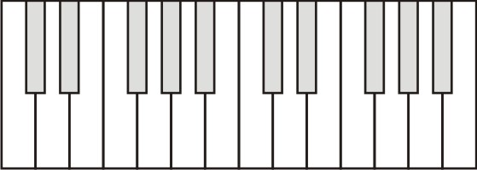
14. Label 13 consecutive piano keys with their note names. For the darkened keys, give either the sharp name or the flat name.

15. If you play all of these notes, from low to high, you are playing what is called a

_____________________________________________

16. Which note letters do not have sharps?

17. Which note letters do not have flats?

18. How many half-steps separate an A from the next E, moving up in pitch? _______

19. Starting from D♭, how many half steps higher is the next F#? ________

20. A major key scale has the following pattern of whole and half steps: __________________________

21. The only major key scale that can be played without using any black keys is the _______ Major scale.

22. Darken and label the keys of a 1-octave C major scale.

23. Darken and label the keys of a 1-octave (8 note) A major scale.

24. A minor key scale has the following pattern of whole and half steps: __________________________

25. The only minor key scale that can be played without using any black keys is the _______ Minor scale.

26. Darken the keys of a 1-octave A minor scale.

27. Darken the keys of a 1-octave C minor scale.

28. Why bother with black and white keys? Why not make them all white?

29. Why are the black and white keys different in size, and why are they in different locations?

String Instruments:
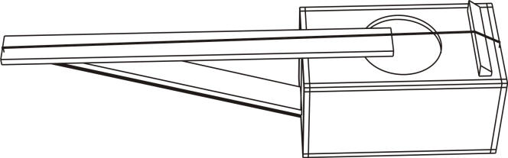

30. Label the nut and the bridge on the string instrument to the right.

31. The diagram below shows an idealized string instrument with frets. The bold line down the middle represents the string.
a. Label the locations of the nut and the bridge.
b. Do you remember the pattern of whole and half steps for a major scale?

c. Darken the frets where you would place your fingers in order to play a 1-octave (8 note) major keyscale.

32. Show a different way to play a 1-octave (8 note) major key scale by darkening the appropriate frets.

33. Do you remember the pattern of whole and half steps for a minor scale?

34. Darken the appropriate frets to show how to play a 1-octave (8 note) minor key scale.

35. Darken the appropriate frets to show another way to play a 1-octave (8 note) minor key scale.

Practice Questions:
1. How many notes are played in a 1-octave scale?
2. How many half steps are there in a 1-octave interval?
3. What major key can be played on a piano without using any black keys?
4. What is the pattern of whole and half steps for a major key scale?
5. What minor key can be played on a piano without using any black keys?
6. What is the pattern of whole and half steps for a minor key scale?
7. Darken the keys of a 1-octave D-major scale.

8. Darken the positions where you would hold down the string to play a 1-octave major scale, starting at the circled fret.
9. Label the nut and bridge of the string instrument on the right.
10. What note has a frequency of 523Hz?
11. How many half steps above G is the next C?
12. Which notes do not (usually) have sharps?
13. Suppose you play a note with a frequency of 6Hz. If you want to play a note that is one half-step higher, what frequency should the new note have? [use a calculator]
14. Suppose you want to play a note that is one octave higher than 6Hz. What frequency should the new note have?

